

**Sports Ground Reservation and Parking System**

**Report submitted by:**

Shams Ihab Hassan 19100334

Nadeen Medhat Labib 19100194

Shady Mohamed Tarek 19100178

Class: 7-6

**Report submitted to:**

Eng. Yasmina Mohamed

**Brief Description:**

Our project’s main purpose is to facilitate the interaction between people and the things they love to do. Nowadays, many people are into sports whether it’s for fun, a hobby or any other reason, which has deprived many people from enjoying their time due to lack of organization. For instance, people could go to a certain court and find it completely booked. Therefore, our project is a system designed for such sport grounds that has many courts to be rented. Adding to this, we wanted to ease it for car owners, so we’ve made a parking system that helps the user to choose the best parking slot for him/her. An invoice is then printed containing the bill details for the court and the parking slot rent per hour.

Our website starts with the home page:

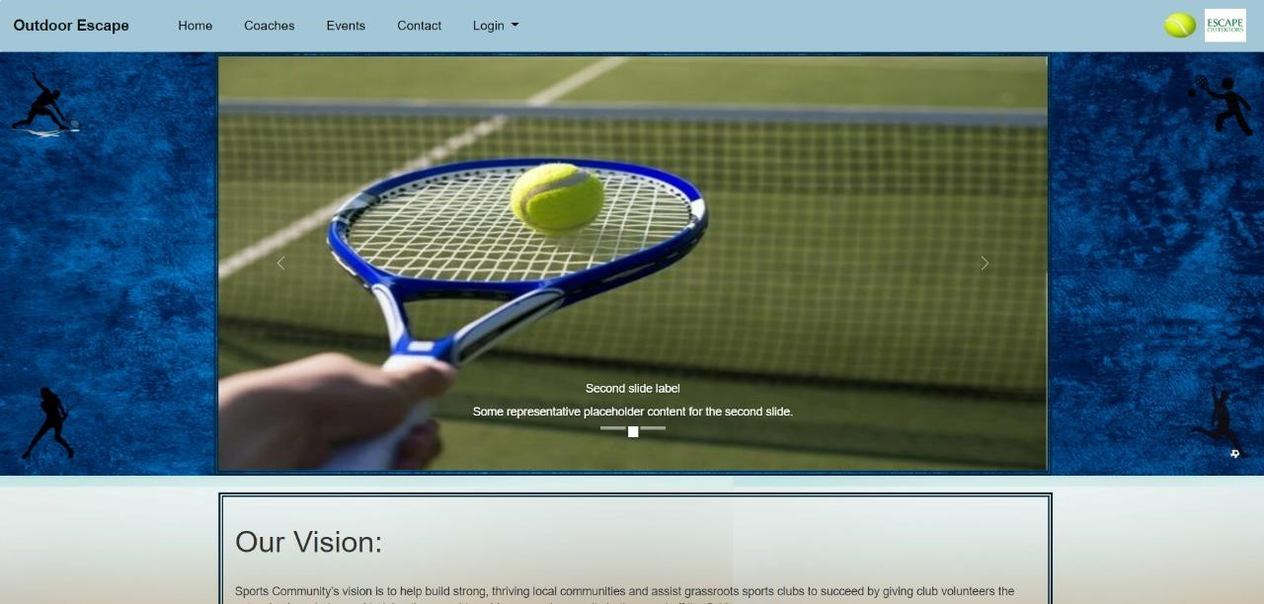

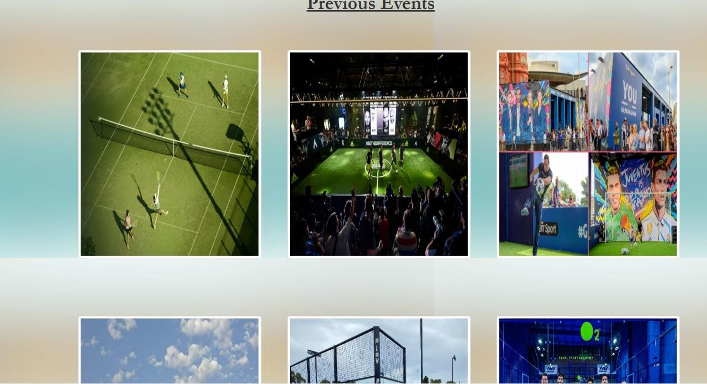

Then to the login form

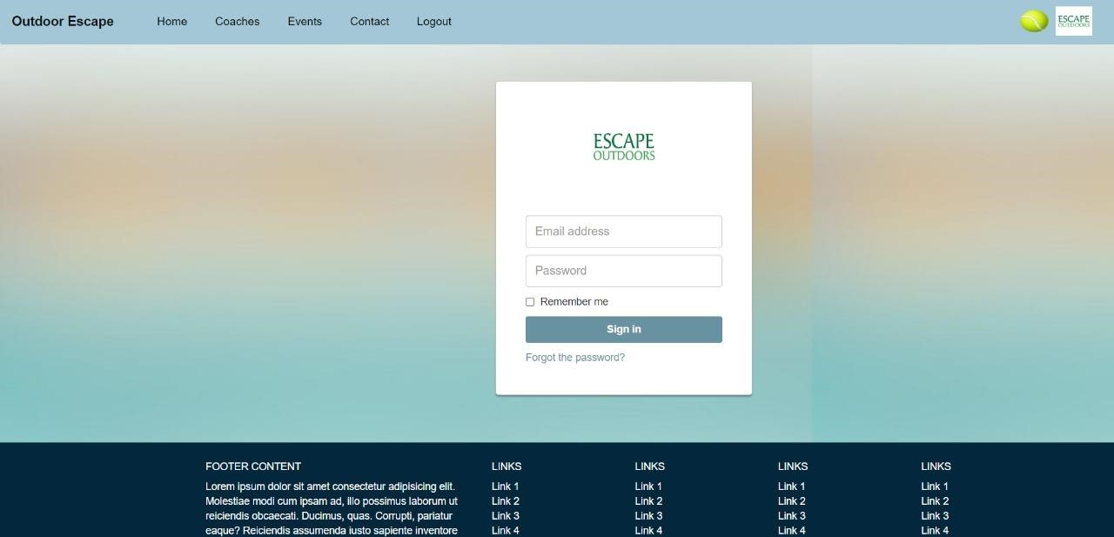

Which takes us to the courts’ reservation

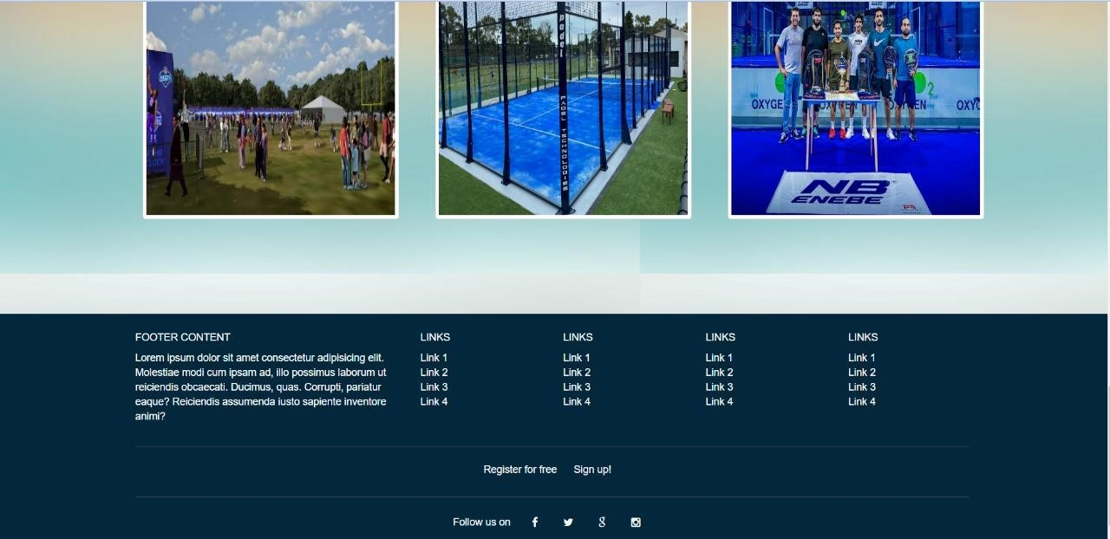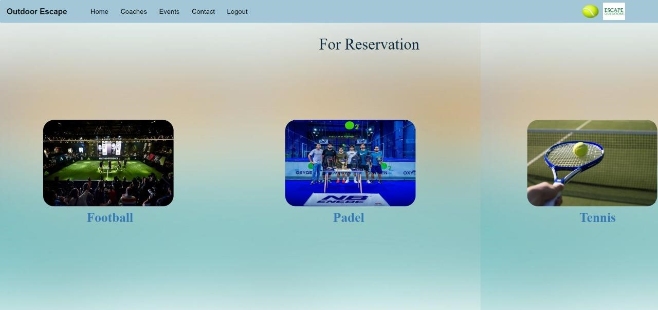

According to the client’s choice of the court, the client is redirected to the reservation form

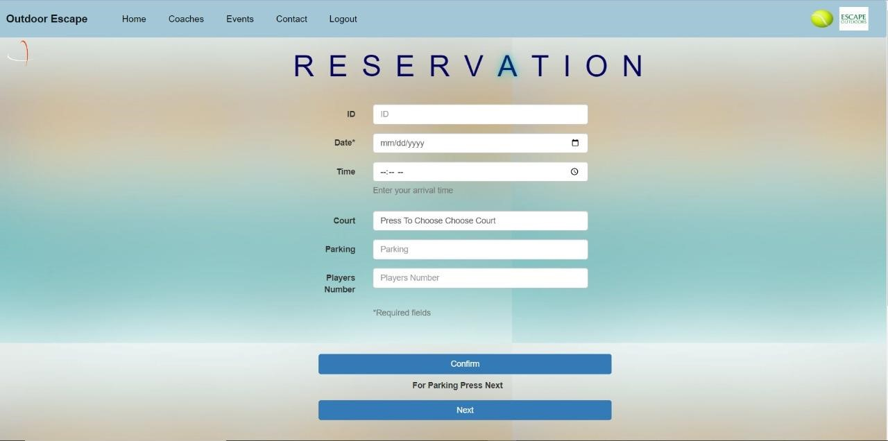

There’s an optional form that appears before confirming the registration which is the parking form

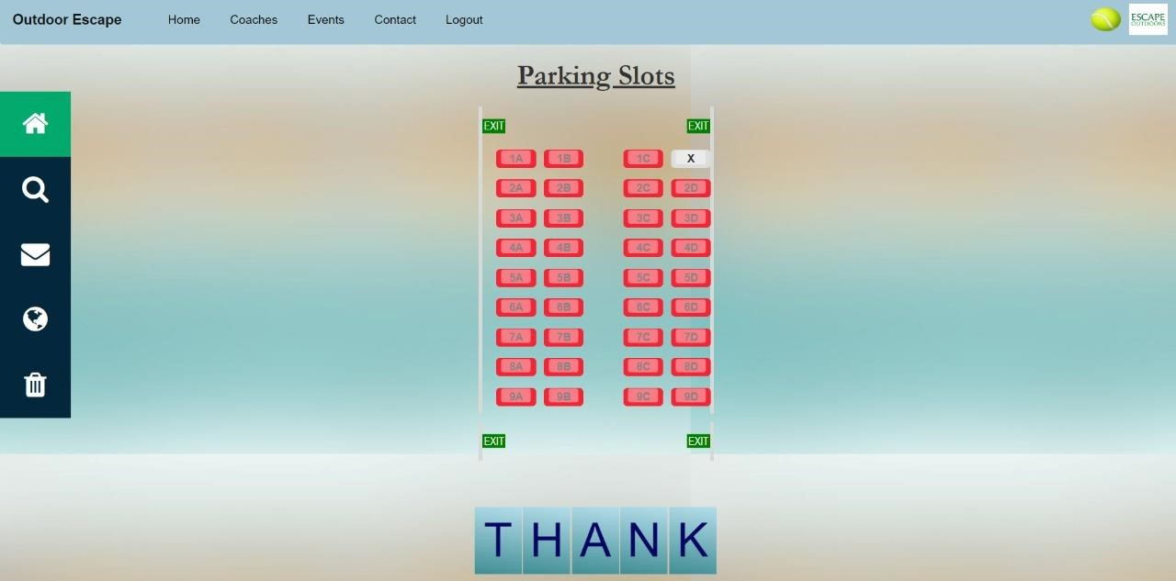

After confirming the registration, we go to the final step which contains the bill details

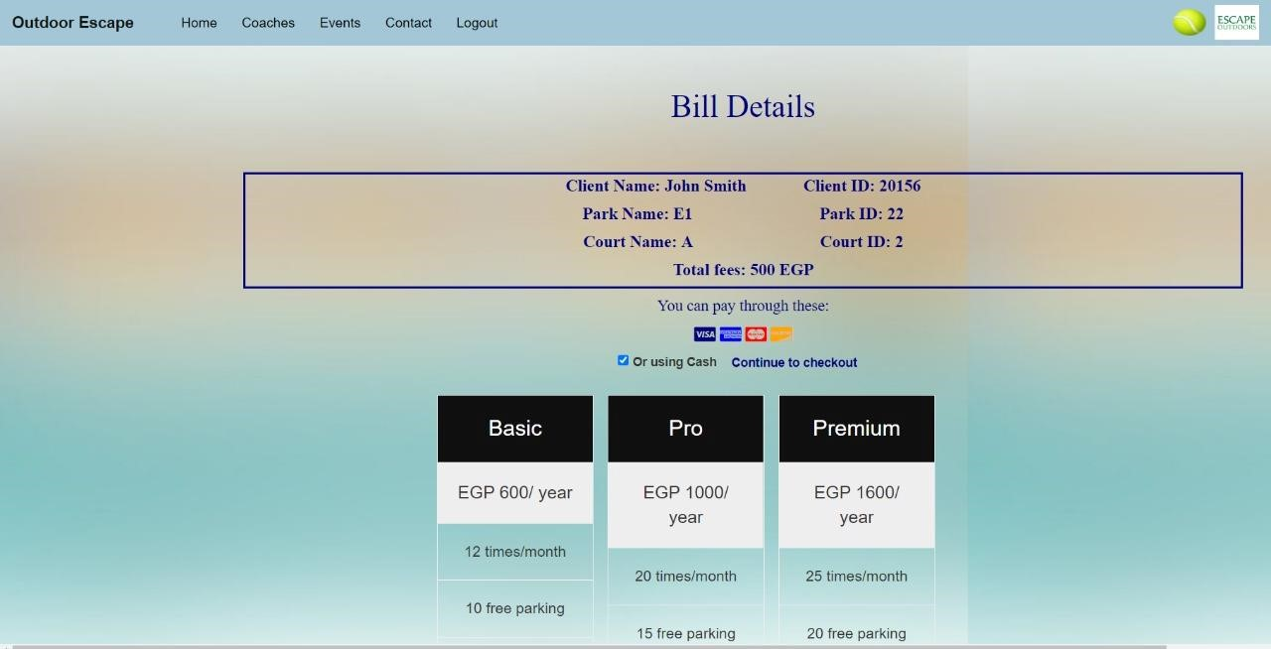

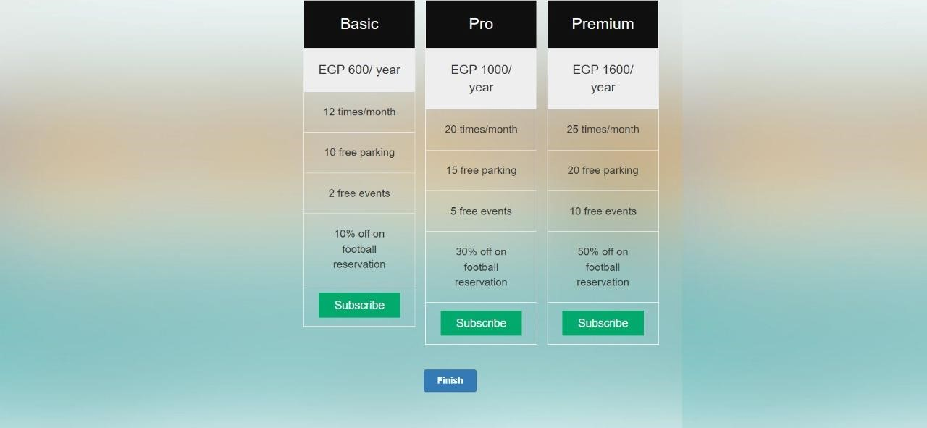

Registration confirmation window



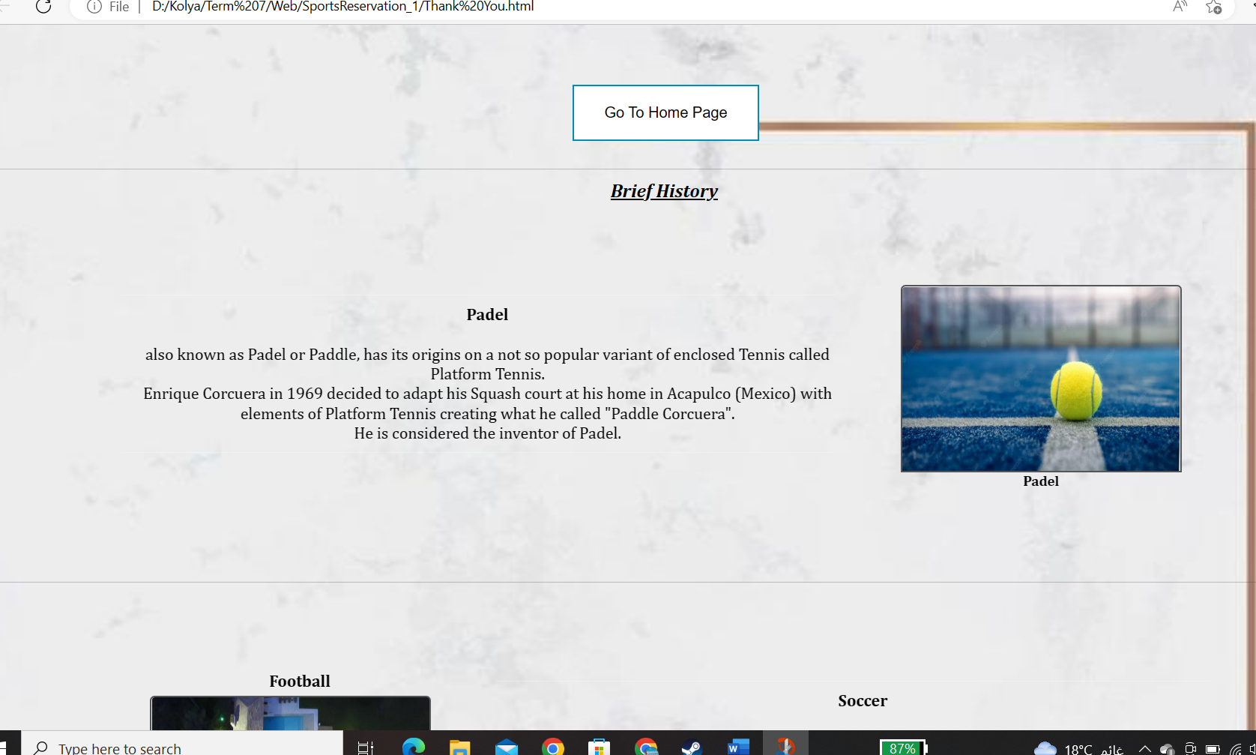

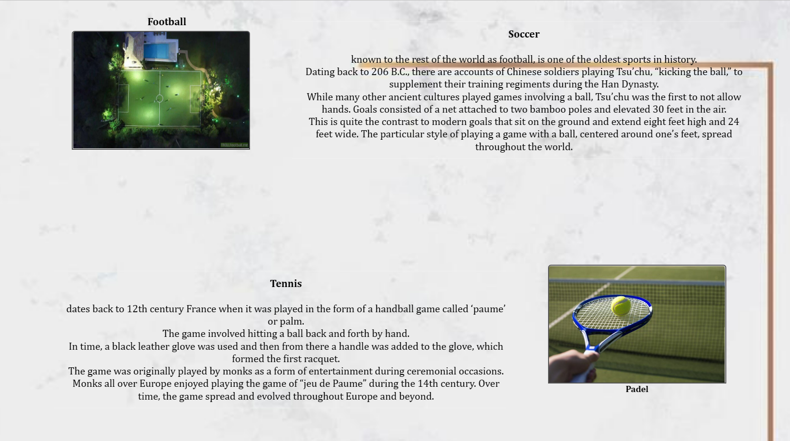

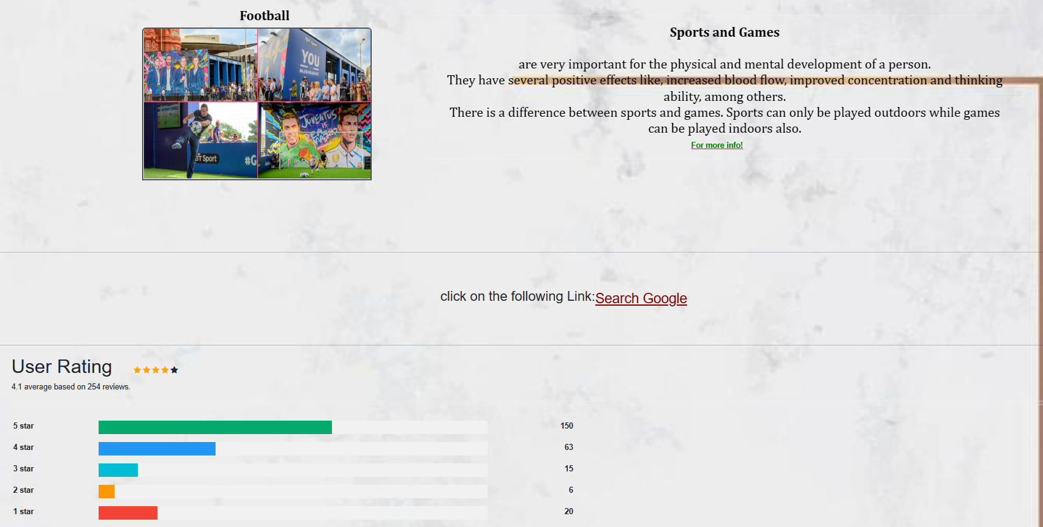

Lastly there’s a coach’s blog page that shows the identity of a coach

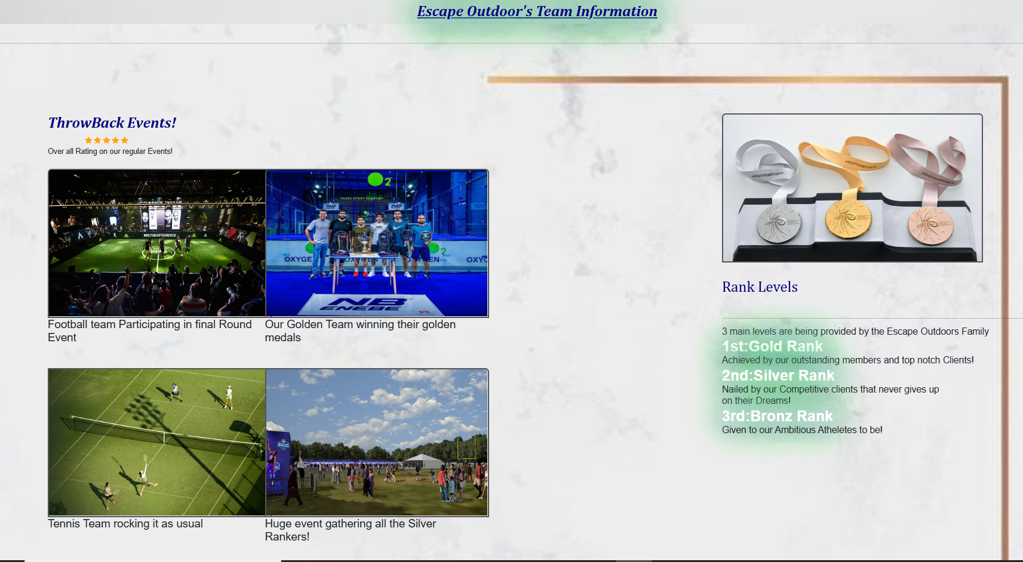

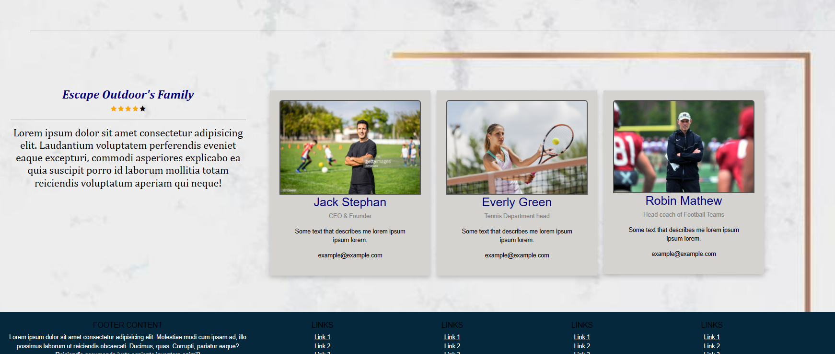

* **Events**

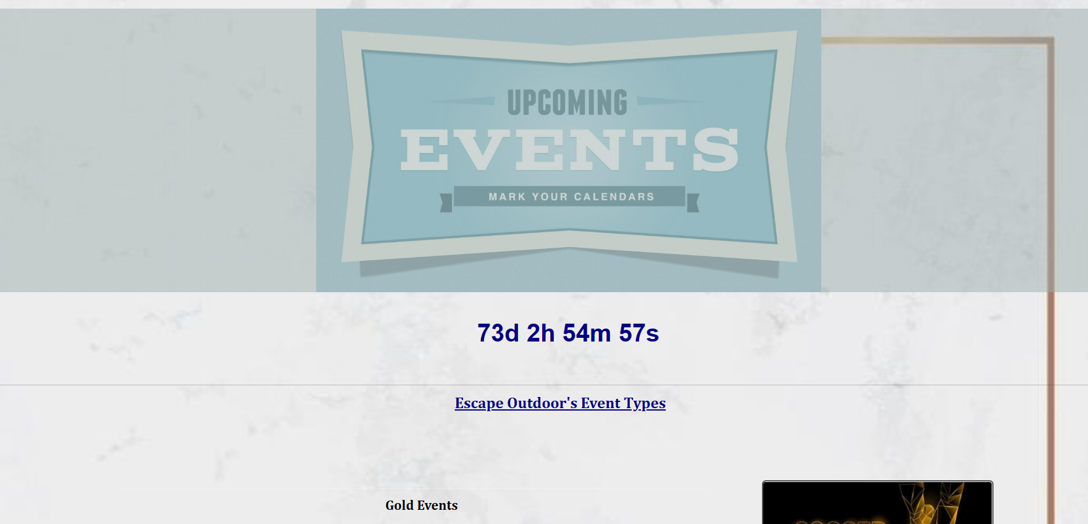

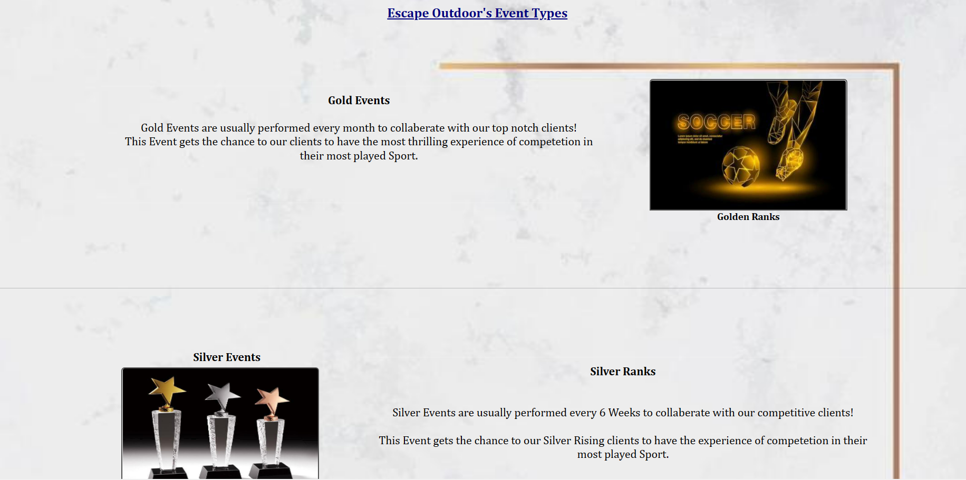

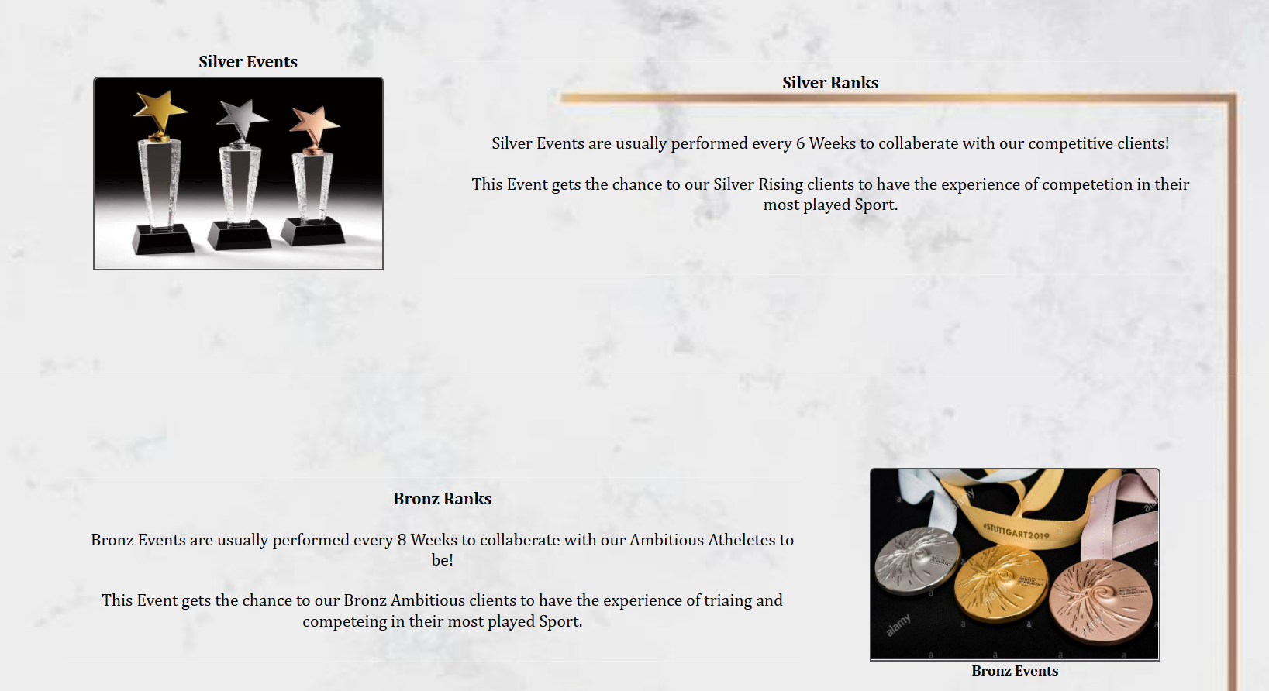

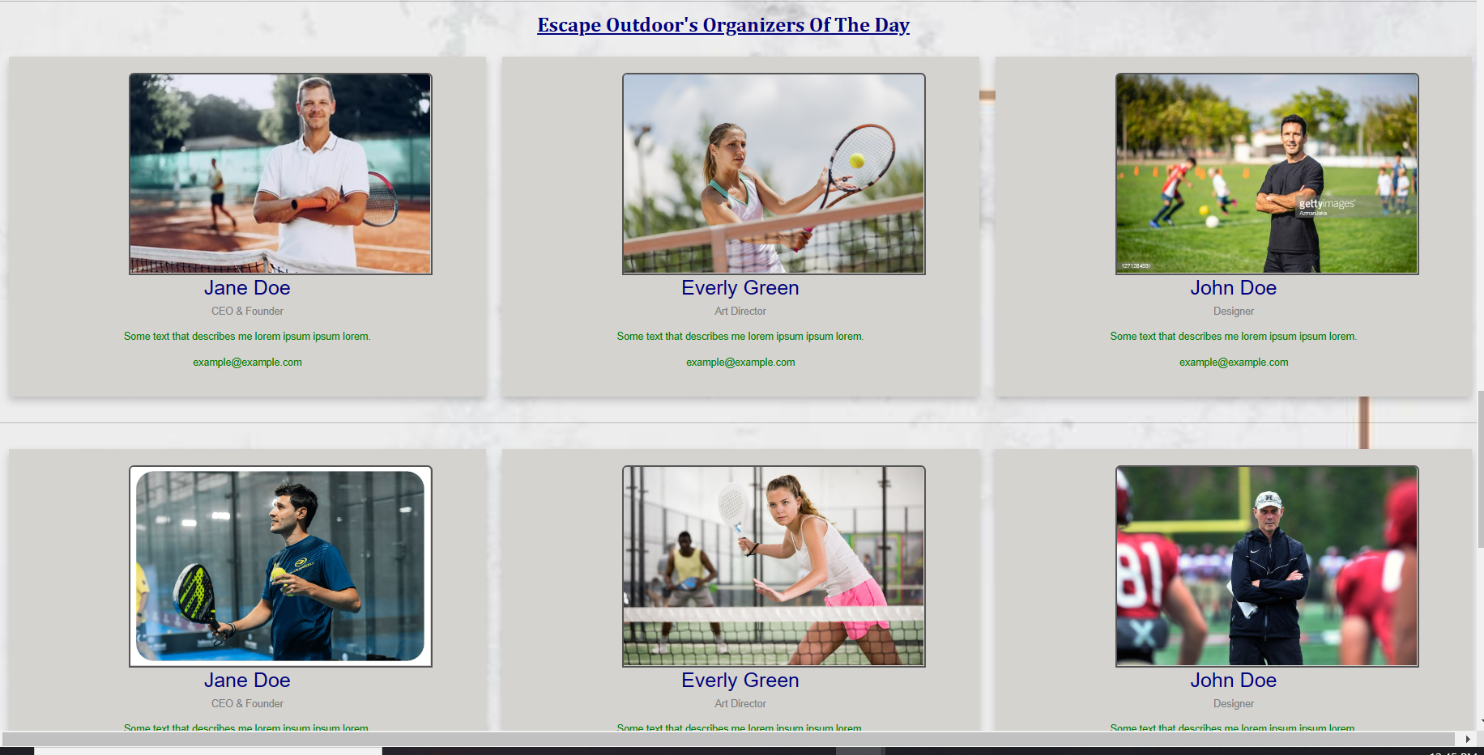

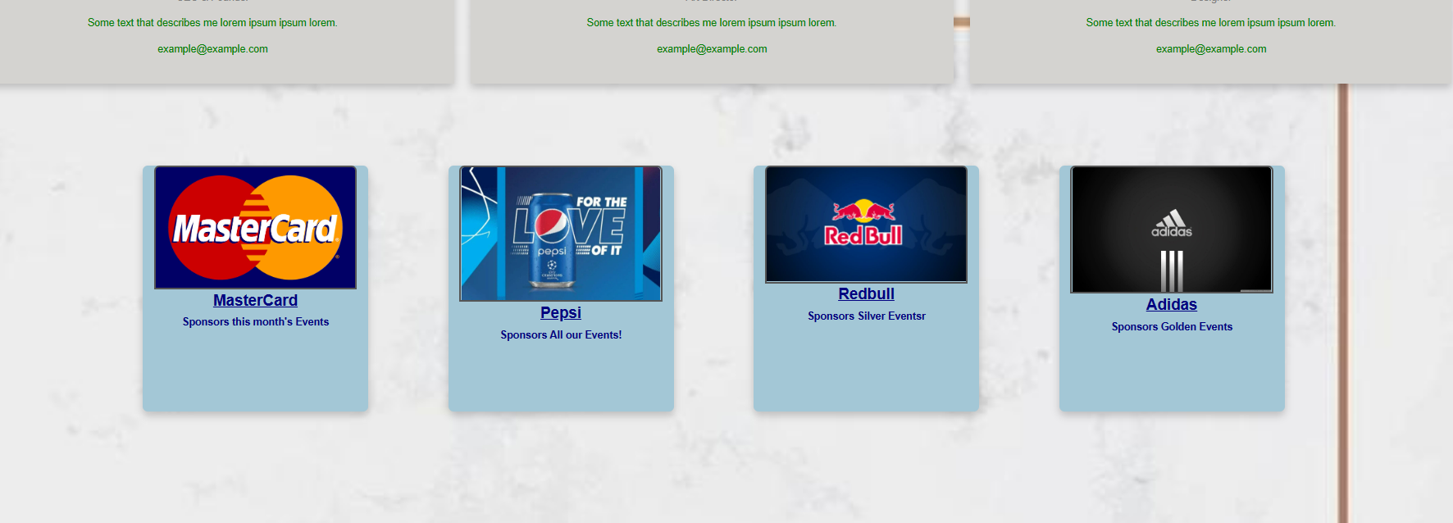

* **Javascript**

